PHYS 202 Spring 2020 Test #1 Name:

$T_{F}=\frac{9}{5}T_{C}+32$ $T_{K}=T_{C}+273.15$

_____________________________

_____________________________________________________________________

A) For the following questions write your answer in the space next to the question #.

____1. Express the temperature 4.2oF in the K unit?  
 a. 223 b. 258 c. 275 d. 277 e. 313

____2. What is the difference in Co of the two temperatures, -45oF and 63oF?  
 a. 42 b. 10 c. 60 d.- 7.8 e. 194

____3. What is the thermometric property of a resistance thermometer?  
a. Length of a liquid column b. Voltage c. Pressure of a gas  
d. Infrared radiation e. Ultraviolet radiation f. Resistance  
  
____4. The third law of thermodynamics is,  
a. The law of conservation of energy.

b. Heat flows spontaneously from a substance at a higher temperature to a substance at a lower temperature.

c. Heat flows spontaneously from a substance at a lower temperature to a substance at higher temperature.   
d. If two systems individually in thermal equilibrium with a third system, then the two systems are in thermal equilibrium with each other.  
e. It is not possible to lower the temperature of any system to absolute zero in a finite number of steps.  
  
____5. Conductors have free_____________.   
a. Protons b. Neutrons c. Atoms d. Nucleons e. Electrons

____6. In thermodynamics the collection of objects upon which attention is being focused is called the ***system,*** while everything else in the environment is called the ***surroundings.*** What is the system for an automobile engine?  
a. Engine b. Radiator c. Wheels   
d. Body e. burning gasoline/air mixture

____7. Walls that permit heat to flow through them are called,   
a. *diathermal walls*  b. *adiabatic walls.*

____8. What is the shape of one of the equipotential surfaces for an isolated point charge?  
____9. What is the shape of one of the equipotential surfaces for a parallel plate capacitor?  
Answers for 8-9  
a. plane b. circle c. sphere d. parabola e. ellipse

____10. An object is charged by contact using a positively charged rod. What type is the charge on the charged object?  
____11. An object is charged by induction using a negatively charged rod. What type is the charge on the charged object?  
Answers for 10 -11:   
A. Positive B. Negative C. No charge

The linear coefficients of thermal expansion are:  
α steel = α concrete = 12x10-6(Co)-1, α aluminum = 23x10-6(Co)-1, α copper = 17x10-6(Co)-1.   
Volume coefficient of expansion of radiator coolant = β = 390 x 10-6 (Co)-1.

 , for solids

12-14) A radiator is made of copper and is filled to its 22.0-L capacity when at  What volume of radiator coolant will overflow when the radiator and coolant reach 1250C?  
____12. What is the change in volume of the coolant?  
____13. What is the change in volume of the radiator?  
____14. What volume of coolant will overflow?  
Answers for 12-14:   
a. 0.129 L b. 0.987 L c. 0.858 L d. 1.12 L e. 0.091 L f. 0.896 L

_____15. Express the SI unit of the electric field in terms of kg, m, s, and C:  
a. $\frac{Kg.m}{C.s}$ b. $\frac{Kg.m^{2}}{C.s}$ c. $\frac{Kg.m^{2}}{C.s^{2}}$ d. $\frac{Kg.m}{C.s^{2}}$ e. $\frac{C.s}{kg.m}$

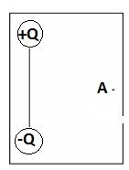

_____16. Two charges +Q and -Q with equal magnitudes are located as shown:   
Point A is at equal distance from the charges. What is the net electric field at A?  
a. Vertical and down b. Vertical and up

c. Horizontal and to the right d. Horizontal and to the left

17-18) Deals with the electric field lines of two charges, magnitudes C and D as shown:

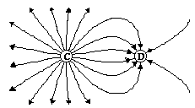

____17. The polarities of the charges are,

a. D is positive and C is negative

b. C is positive and D is negative

c. Both are positive d. Both are negative

_____18. The ratio C/D is given by,  
a. 0.44 b. 0.66 c. 1.5 d. 2.25 e. 3.0

$Q=mc∆T$ $Q=mL$ $({COP)}_{Heat Pump}=\frac{Q_{H}}{W}$

B. The humidifier operates just like a heat pump and has a coefficient of performance of 3.8. The water going into the unit has a temperature of 18°C, and it needs to produce steam at 100°C at a rate of 2.5 kg/hour. Find the power, rate at which it does work, of the humidifier.  For water: c = 4186 J/(kg·C°),  Lf= 3.35x105 J/kg,  Lv= 2.26 x106 J/kg

C. Coulomb’s law is given by: F:\PHYS202\Study Guides\sgt2CouLaw.gif Coulomb’s constant = k = 9 x 109 (SI)  
1.Figure below shows three point charges that lie along the x axis in a vacuum,   
with no gravity.   
a. Draw a free-body diagram for the charge Q2.  
b. Determine the magnitude and direction of the net electrostatic force on Q2.



Gas constant = R = 8.31 J/mol.K, NA = 6.022 x 1023.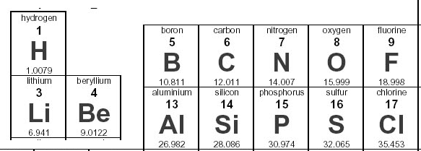  
D. The active ingredient in the allergy medication Claritin contains carbon (C), hydrogen (H), chlorine (Cl), nitrogen (N), and oxygen (O). Its molecular formula is C22H23Cl N2O2. The standard adult dosage utilizes 1.704 x 1019 molecules of this species.   
1. What is the molar mass of Claritin?

2. Determine the mass (in grams) of the active ingredient in the standard dosage.

∆U = Q - W. W= P.∆V = area under the P vs. V curve.   
E. An ideal gas is taken through the three processes (A→B, B→C, and C→A) shown in the drawing, where CA is an isotherm.   
  
1. Name the process **AB** ____________________ and **BC**_______________________.  
2. For the three processes shown in the drawing, fill in the eight missing entries in the following table.

|  |  |  |  |  |  |  |  |  |  |  |  |  |  |  |  |  |  |  |  |  |  |  |
| --- | --- | --- | --- | --- | --- | --- | --- | --- | --- | --- | --- | --- | --- | --- | --- | --- | --- | --- | --- | --- | --- | --- |
|  | | | |  |  |  |  | | --- | --- | --- | --- | | Process | ∆U | Q | W | | A→B | b. | +67,000 J | a. | | B→C | d. | e. | c. | | C→A | f. | g. | 62,000 J |   h. Area of the shaded shape ABC= | | | |
|  | $$x=\overline{v} t$$ |  | |  | $$\vec{F}=m\vec{a}$$ $$\vec{E}=\frac{\vec{F}}{q}$$ |

F. Figure below shows an electron passing between two charged metal plates that create an electric field of 425 N/C, perpendicular to the electron’s original horizontal velocity. The initial speed of the electron is 2.50×106 m/s, and the horizontal distance it travels in the uniform field is 7.50 cm.   
(a) Sketch the electric field between the plates.  
(b) Sketch the path of the electron as it travels between the plates and exits.   
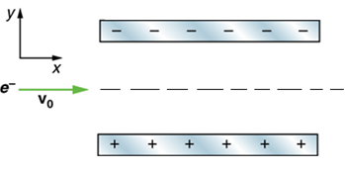  
(c) How long will it take the electron to cross the plates?

(d) What is the vertical acceleration of the electron? [me = 9.11 x 10-31kg, |qe| = 1.6 x 10-19C]

(e) What is its vertical deflection of the electron?

(f) What is the vertical component of its final velocity?

(g) What is the total speed of the exiting electron?